DSMM-GP4

Visualizations, Leadership and Management Communications

Power Business Intelligence

Submitted by: Anu Bala(c0718191)

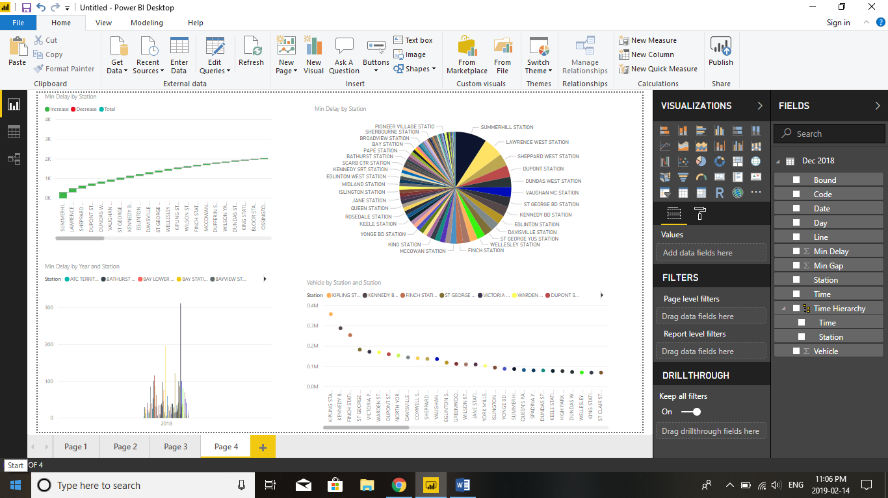

This is the dashboard that I make on power Bi and in the coming pages I will explain all the visuals that I used for visualisation.

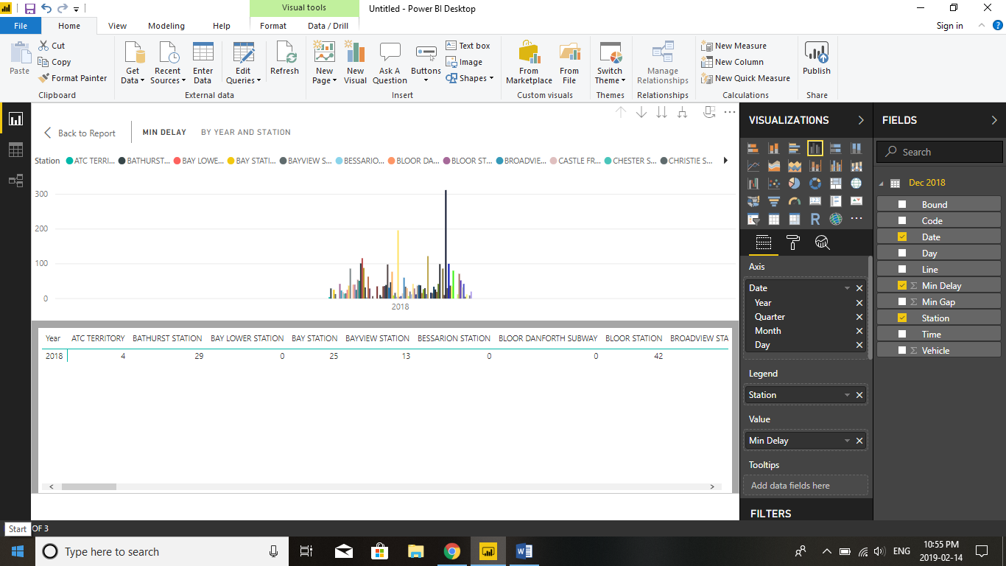

In clustered column chart, it is clearly shown in the figure about the subway that was delay 42 times in bloor station and minimum delay 4 times in Atc territory station.

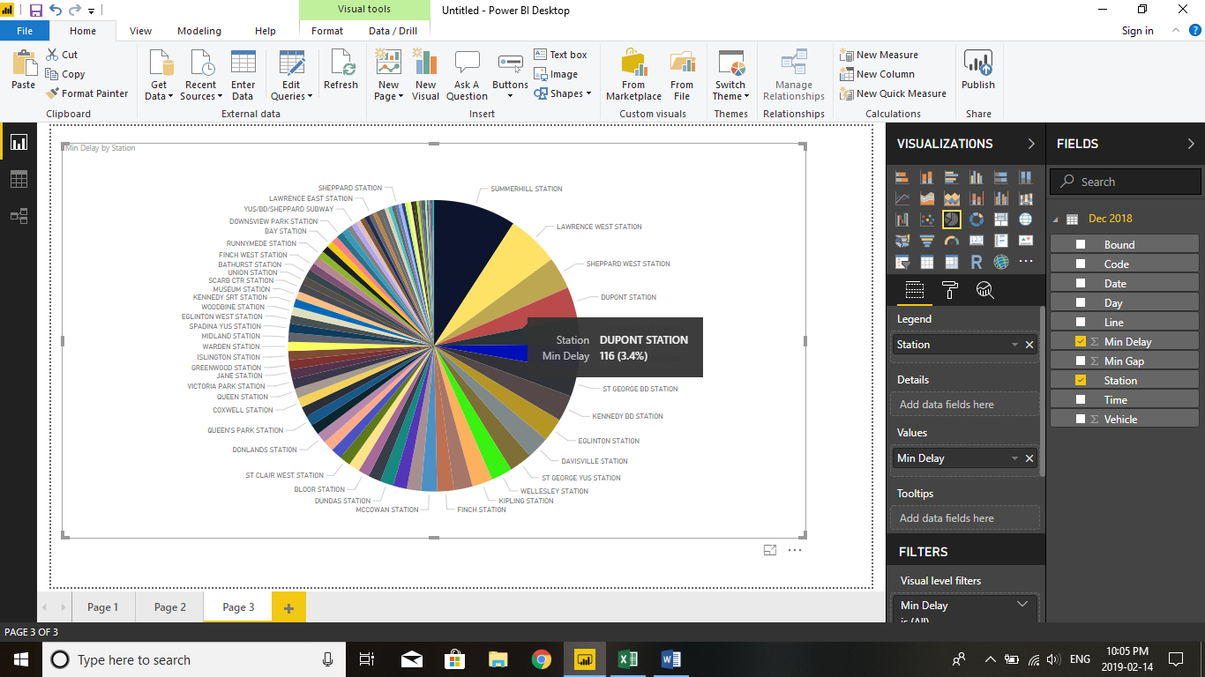

This is the pie chart which describes the station codes and min delay like the blue color shows the maximum percent of subway min delay as compared to others.

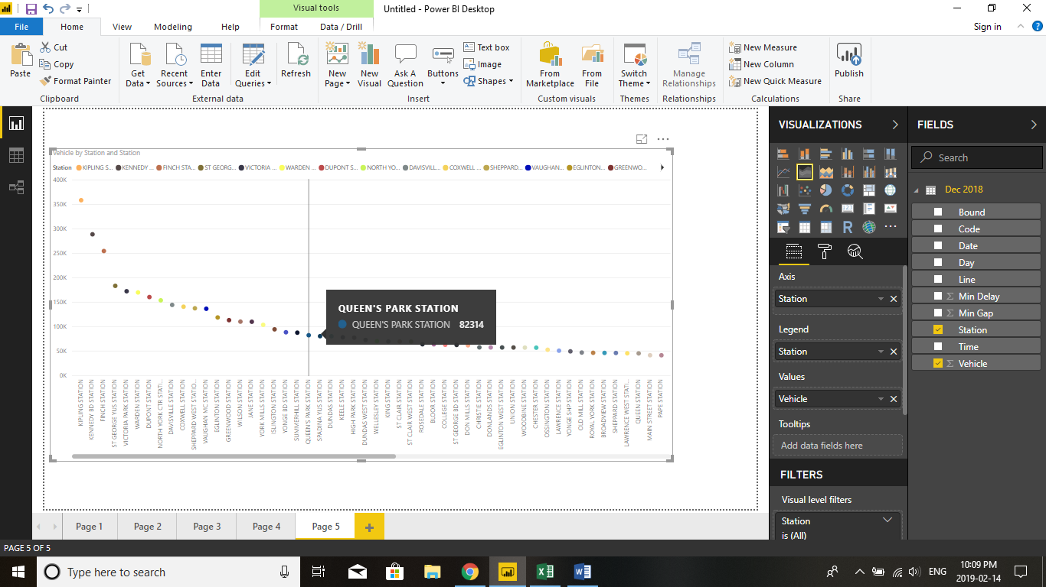

This is the area chart that describes the vehicle and station. All the stations are labelled with different colors and vehicle labelled as the plate number of subway. Like in figure, At queen park station the subway with 82314 will come on their schedules.

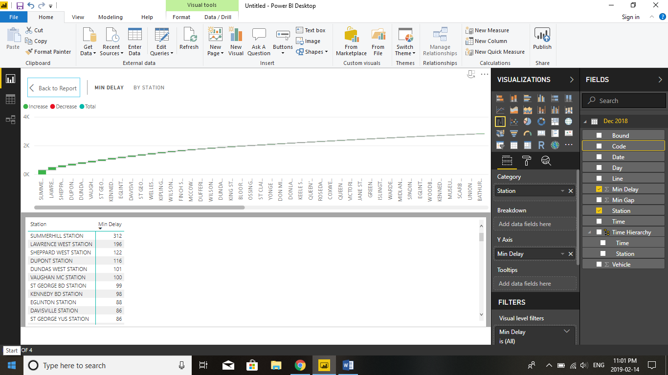

In this figure, I used waterfall chart which describes the station and min delay. The green color shows the min delay of subway in particular station and red color shows the decrease level.